Case Study 89: University Hostel Room Allocation
1. Problem Statement
Allocate students to hostel rooms according to room capacity and eligibility constraints. Detect duplicate assignments and calculate unallocated demand.
2. Objectives
Allocate eligible students without exceeding room capacity.
Avoid assigning a student more than once.
Identify students who cannot be allocated.
Display remaining room capacity.
3. Assumptions
Each room has a fixed capacity and a permitted category (Boys or Girls).
Students can only be assigned to rooms of the matching category.
Students are processed in the order provided.
No room can exceed its capacity.
4. Algorithm
Create room records with category and capacity.
Create student records with category.
For each student, search for the first matching room with space.
Assign the student if a suitable room is found.
Track unallocated students and remaining capacity.
Display allocation summary.
5. Flowchart
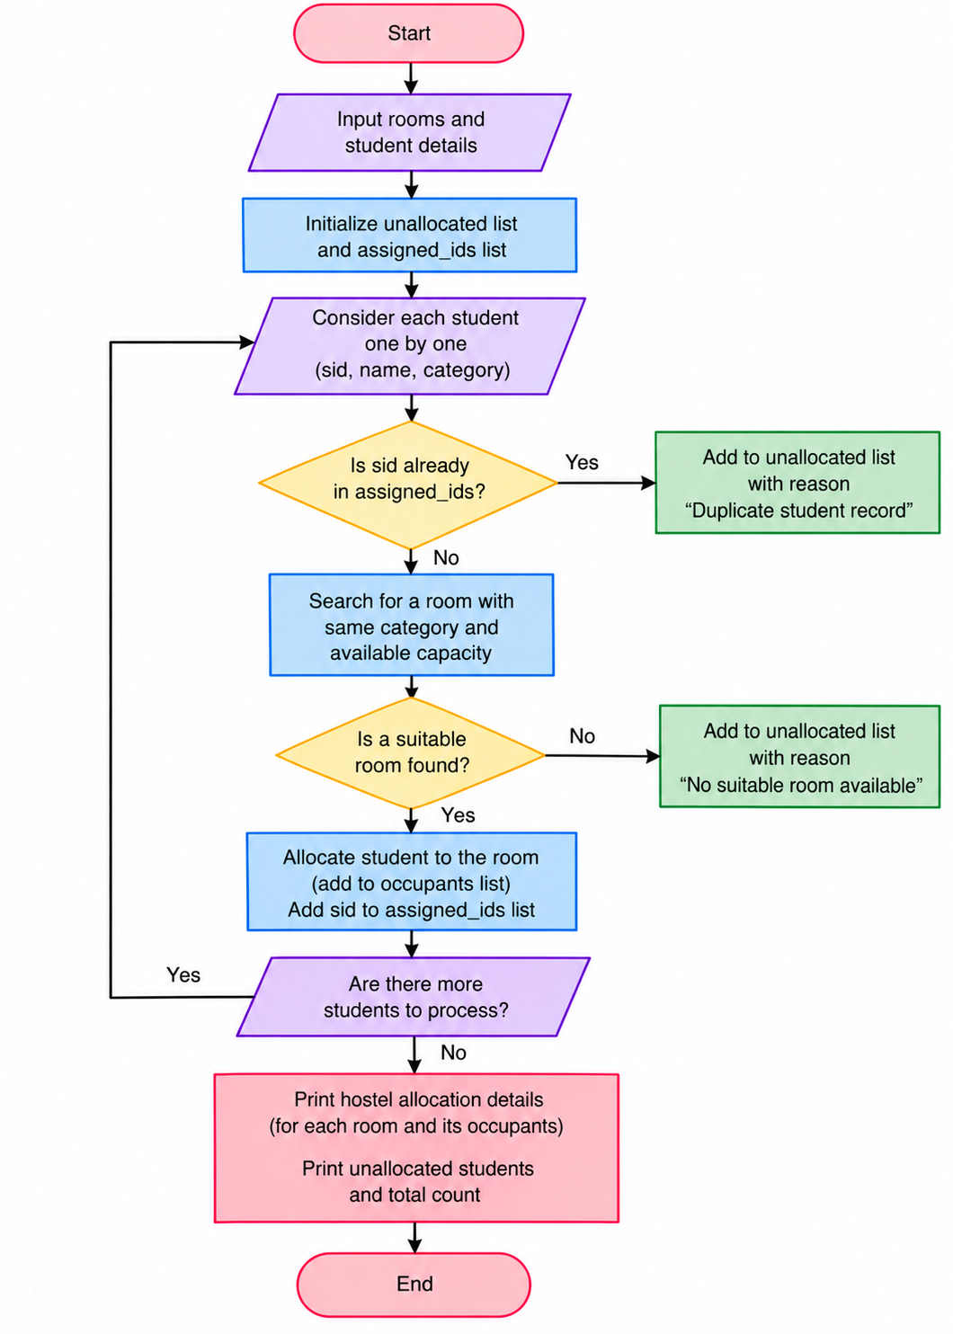
6. Pseudocode
START
Create room records with category and capacity.
Create student records with category.
For each student, search for the first matching room with space.
Assign the student if a suitable room is found.
Track unallocated students and remaining capacity.
Display allocation summary.
Display result
STOP

7. Test Cases
Input / Record | Expected Result
S101 | Allocated to G101
S105 | Unallocated because girls' rooms are full
S107 | Unallocated because boys' rooms are full
8.Output Screenshot
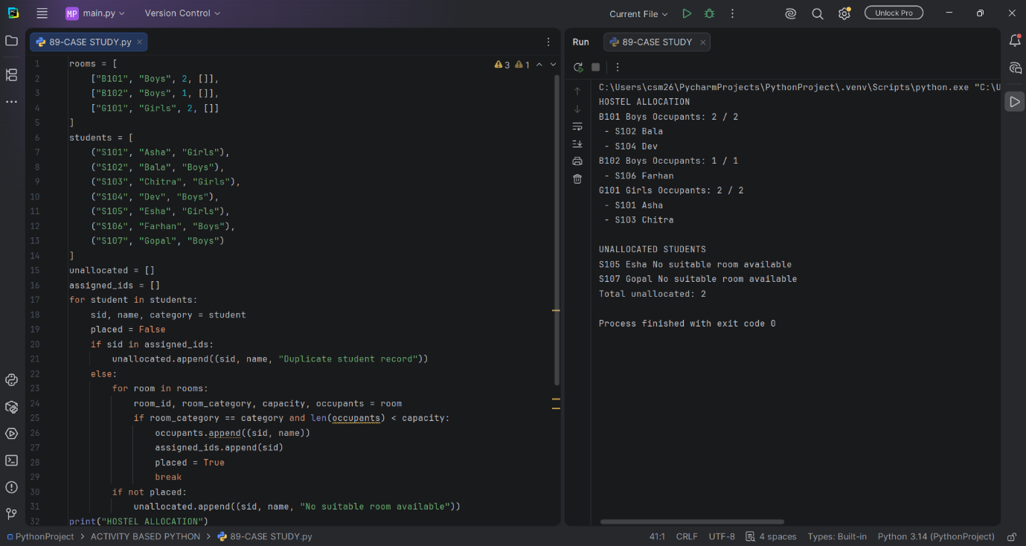
9. Conclusion
The program allocates students to suitable rooms, respects room capacities and reports unallocated demand.

